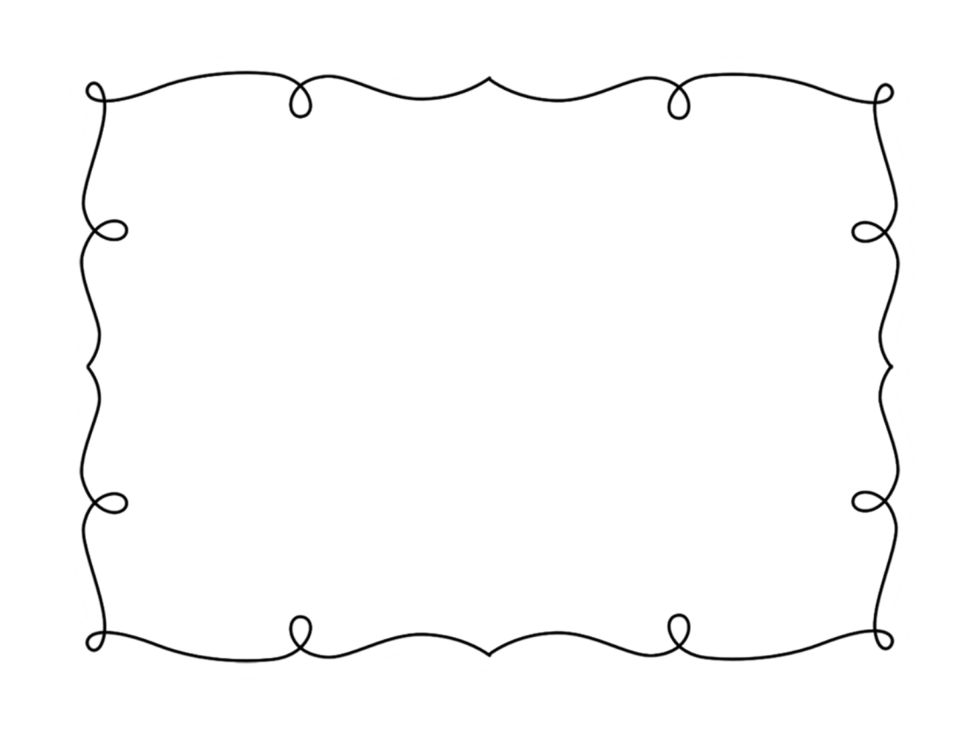
Name: ______________________ Week of: ________
My Weekly AR Reading Goal
This week I will read ____ books.
My books should be a ____ to ____ level.
Title | Author | Level | Score

Parent Signature: ___________________________
www.thecurriculumcorner.com

