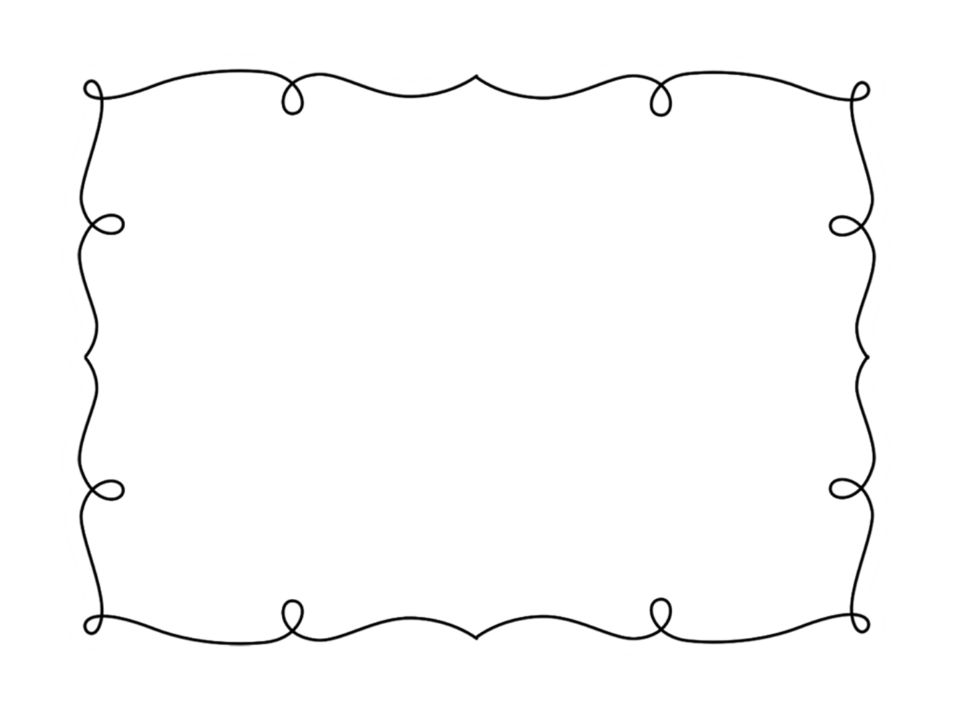
Name: ______________________ Week of: ________
My Weekly Reading Goal
This week I will read ____ books.
Books I’ve Read
Title | Author

Parent Signature: ___________________________
www.thecurriculumcorner.com

