April 27th, 2015
Dear Families,
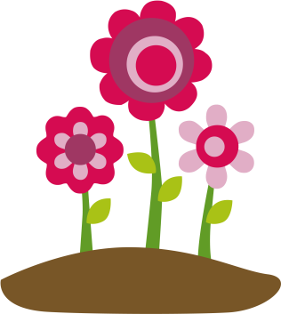
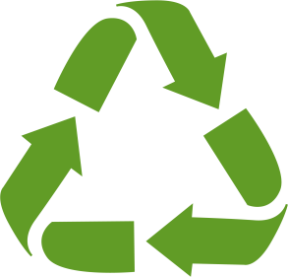
This week we will have another creative homework assignment. In class we have been talking about ways we can work to be more a little more “green” in our lives. We have talked over ideas such as recycling and remembering to turn off the lights when we leave the room. As a class, we have made a commitment to work together to make these behaviors a part of our classroom habits. Each family now has their own job. Students are bringing home a family pledge certificate. This week your job as a family is to meet and discuss what steps your family can take to help the environment. You will choose one action to add to your pledge certificate. You will then display this certificate in a prominent place in your home. Each day for the next two weeks, you will meet in the evening to track your progress on the log you will receive. When the two weeks is up, your students will bring in their pledge certificates and logs. As a class we will discuss what changes we made and how we have helped the environment. Send me a message if you have any questions!
Sincerely,
Mrs. Henry

