Hospital Packing List

Toiletries
- lotion/moisturizer
- chapstick/lipgloss
- toothbrush/toothpaste
- shampoo/conditioner/soap
- styling products
- razor/shaving gel
- deodorant
- hair accessories
- makeup
- makeup wipes
- contacts/solution
- glasses
- nursing pads/Lansinoh
Clothes
- pajamas
- 2 nursing bras
- yoga pants
- nursing top
- cardigan
- slippers/flip flops
- underwear/ socks
Entertainment/ Communication
- iPad/laptop/chargers
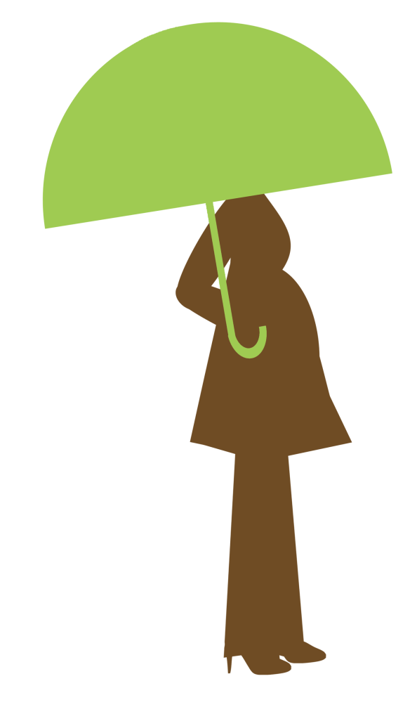
- camera/battery/charger
- Scrabble
- sibling gifts
For Baby
- baby mittens
- nail clippers
- going home outfit
- receiving blanket
- hat
- Boppy
- car seat

