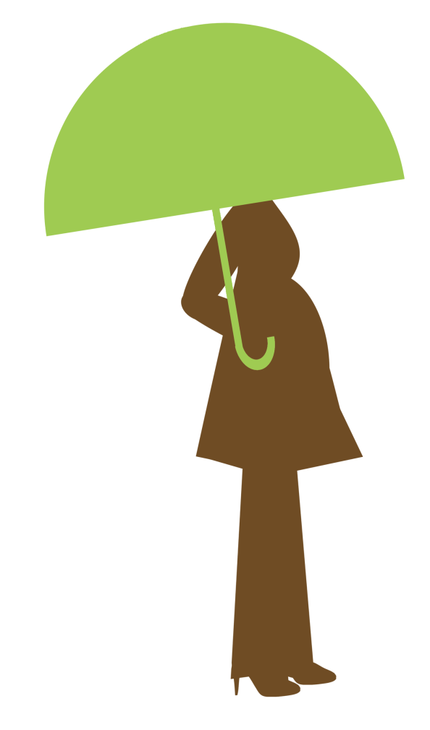
The Siblings

Big Brother
- wake up at 7:30
- clothes are on his chair/ get dressed/brush teeth
- pack lunch – pbj/applesauce/Goldfish/Oreos/juice box (navy lunchbox)
- bus arrives at 8:35

Middle Brother
- wake up at 7:30
- clothes are on his chair/get dressed/brush teeth
- pack lunch – pbj/apple/Goldfish/granola bar/
juice box (black lunchbox)
- bus arrives at 8:35

