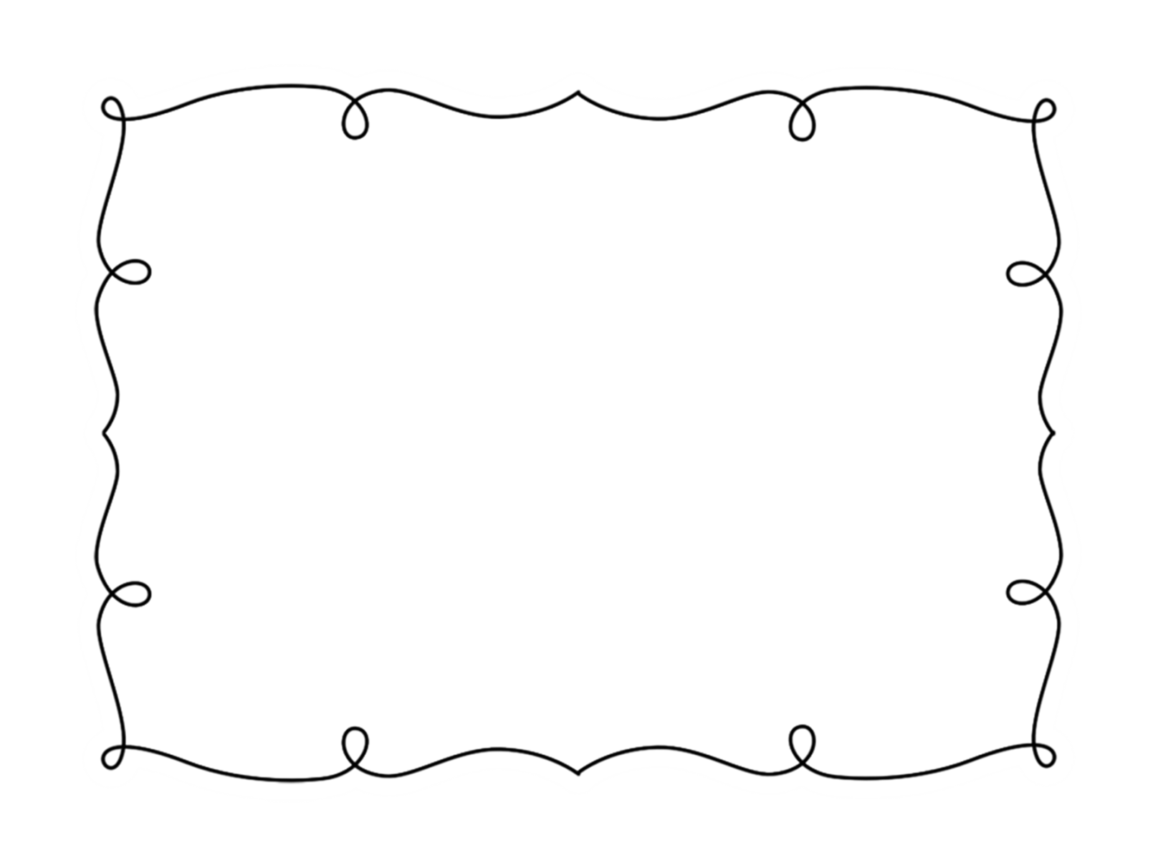
__________’s

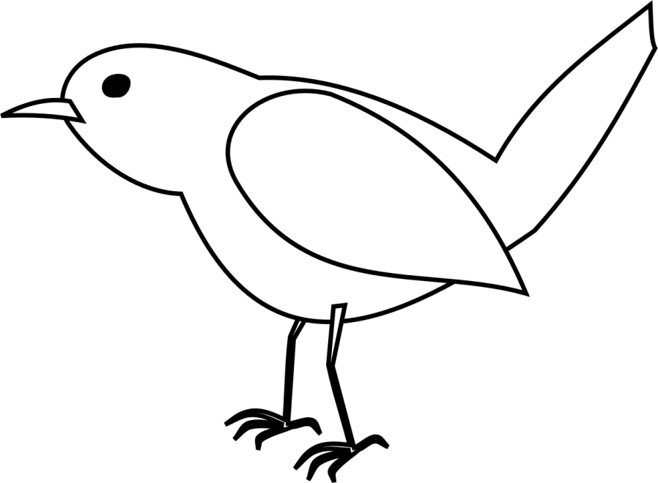
© www.thecurriculumcorner.com
Bournal

__________’s

Bird Journal

© www.thecurriculumcorner.com

Bird Web
Directions: Create a web to share what you already know about birds. Remember to group similar ideas together.

Birds

I Wonder…
Directions: What do you wonder about birds? Write your questions below.
______________________________________________________________________________________________________________________________

______________________________________________________________________________________________________________________________

______________________________________________________________________________________________________________________________

______________________________________________________________________________________________________________________________

Home Sweet Home
Directions: Draw a picture of the nest you see. Label what you see. Write you observations below.

______________________________________________________________________________________________________________________________________________________________________________________________________________________________________________________________________________________________________
Close your eyes & listen!
Directions: Go outside and close your eyes. Open your ears and listen to the birds around you. Draw and write to share what you hear. How do the sounds make you feel?

Clay Birds
Directions: Use the clay to make a bird. Remember to include the parts of the bird you have learned about. Use a picture to help you. When you are finished, draw a picture of your bird. Remember to include labels.

Eagle Cam
Directions: As you watch the camera, what do you see? What connections can you make? What questions do you have about what you see?

______________________________________________________________________________________________________________________________________________________________________________________________________________________________________________________________________________________________________
Falcon Cam
Directions: As you watch the camera, what do you see? What connections can you make? What questions do you have about what you see?

______________________________________________________________________________________________________________________________________________________________________________________________________________________________________________________________________________________________________
Caring for the Eggs
Directions: Draw a picture to show the eggs and how you are keeping them safe and warm. Write to tell about what you drew below.

______________________________________________________________________________________________________________________________________________________________________________________________________________________________________________________________________________________________________

Hatching Eggs
Directions: Draw a picture to show what you see as the eggs begin to hatch. What sounds do you hear?

______________________________________________________________________________________________________________________________________________________________________________________________________________________________________________________________________________________________________
Taking Care of the Chicks
Directions: Think about what you need to do to take care of the chicks. What responsibilities do you have? Why is it important for you to do your jobs carefully?

______________________________________________________________________________________________________________________________________________________________________________________________________________________________________________________________________________________________________
Research
I read the book: __________________________________
The author was: __________________________________
Draw a picture and use words to share what you learned. Remember to include facts. Label your picture.

______________________________________________________________________________________________________________________________________________________________________________________________________________________________________________________________________________________________________

___________________________________
___________________________________

Bird Word Wall

