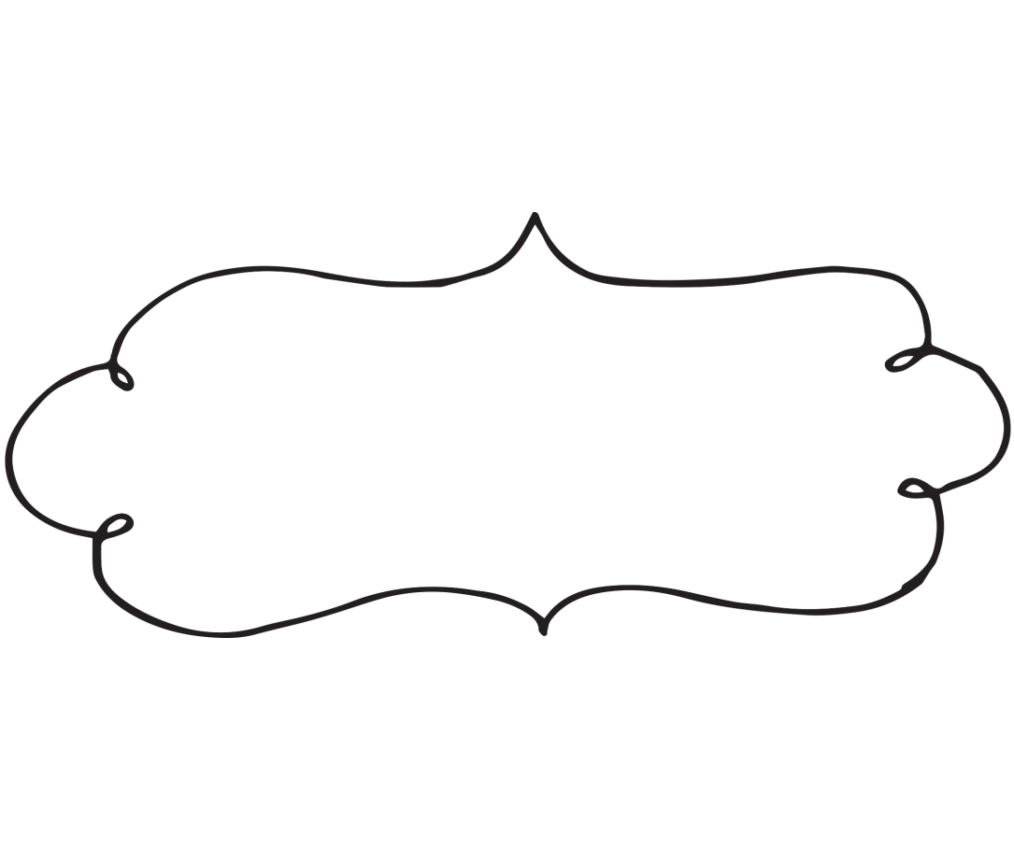

Supports Needed!

Teacher: ____________

Student:

Student:

Student:

Student:

Student: