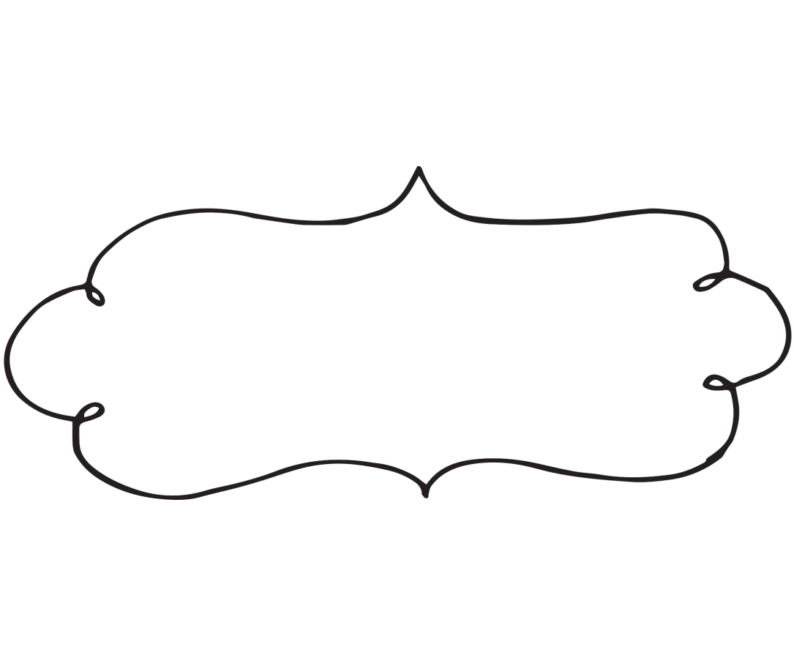

Things to do!

Week of ___________________

Monday

Monday

Monday

Monday

Monday